
Miniature Thermocouple Connector Plug
AM-J-M Type J ANSI
XE-9060-001
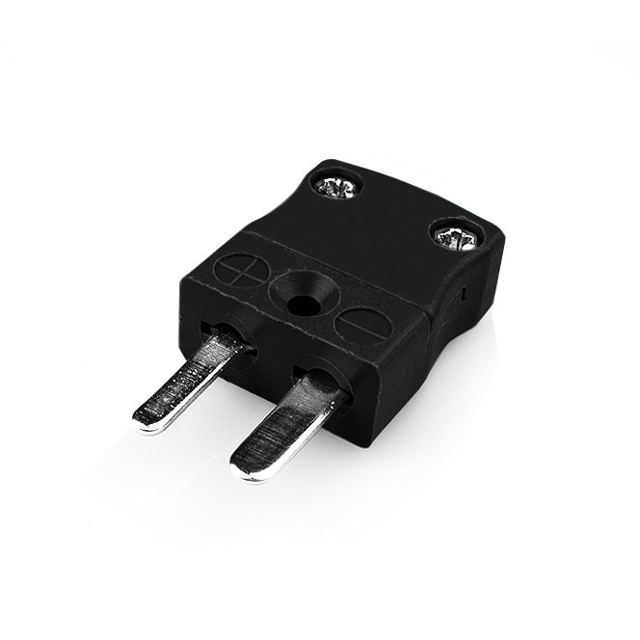

Labfacility are the UK’s leading manufacturer of Temperature Sensors, Thermocouple Connectors and associated Temperature Instrumentation and stockists of Thermocouple Cables. The Company has been trading since 1971 and is ISO 9001 accredited.

Specifications
General Description | Ideal for general purpose use. Contacts are polarised to ensure correct connection.
Thermocouple Type | J ANSI
Connector Type | Plug
Connector Size | Miniature
Colour | Black
Max. Temperature | 220°C
Pins | Flat Pins
+Positive Contact | Iron
-Negative Contact | Copper Nickel
Standards Met | BS EN 50212:1997. RoHS

Ordering Information
Thermocouple Type | Colour Code | Type | Order Number
J | ANSI | Plug | XE-9060-001
