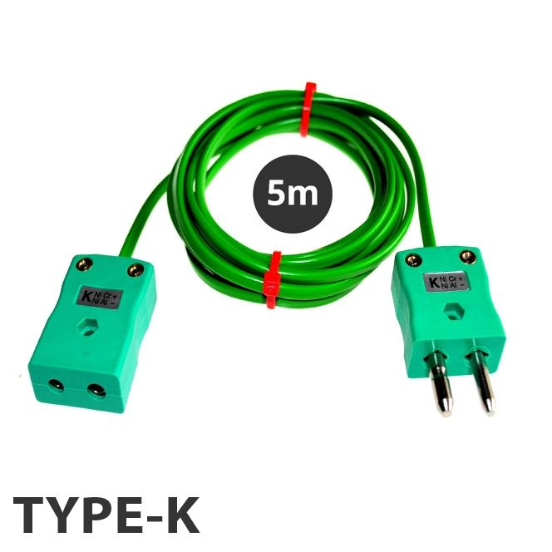

IEC Extension Lead PVC Flat Pair Type K Standard Plug / Socket 5M (16.4Ft)
XE-7013-001

Labfacility are the UK’s leading manufacturer of Temperature Sensors, Thermocouple Connectors and associated Temperature Instrumentation and stockists of Thermocouple Cables. The Company has been trading since 1971 and is ISO 9001 accredited.

General Description | Good general purpose insulation for 'light' environments. Waterproof and very flexible.
Cable Length | 5M
Cable Type | Flat Pair Construction
Connector Type | Thermocouple Plug & Socket
Connector Size | Standard
Core / Strands | 7/0.2mm
Conductor Cross Section 7/0.2 (mm2) | 0.219
Outer Colour | Green
Drain Wire | No
Insulation Material | PVC Insulated
Loop Resistance 7/0.2 (Ohms per combined metre) | 4.5
Max. Temperature | 105°C
Min. Temperature | -10°C
+ Conductor | Nickel Chromium
- Conductor | Nickel Aluminium
Screen | No
Standards Met | Colour code (cores & jacket) to IEC-584-3
Thermocouple Type | K
Termination Type | Standard Thermocouple Plug and Socket
Tolerance | Class 2

Ordering Information
Thermocouple Type | Colour Code | Size | Termination | Order Number
K | IEC | 5m | Standard Plug & Socket | XE-7013-001

